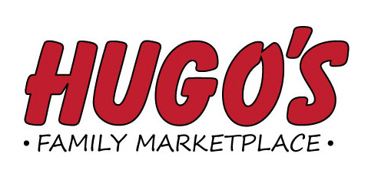
Job Opening
Produce Assistant Manager – Grand Forks
Hugo’s #12 – Downtown Store
Duties Include: Providing outstanding Customer Service,
merchandising, department training activities, ordering,
monthly inventory, maintaining department quality standards,
ensuring pricing accuracy, book work and supervisory duties.

Please send resume to:
Hugo’s Human Resource Dept.
1950 32nd Avenue S. Suite C
Grand Forks, ND 58201
Applications will be taken through May 15th

