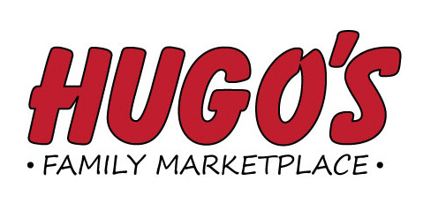
Job Opening
Customer Service Counter Manager
Hugo’s #2 (1631 South Washington Grand Forks)
Duties Include: Providing Outstanding Customer Service. Supervising and training other service counter associates, managing time keeping system, coordinating accounts receivable, scheduling, ordering tobacco, managing all aspects of the Customer Service Counter, assisting the front end cashiers as needed.
Please send application to:
Hugo’s Retail Support Center
1950 32nd Avenue South Suite C
Grand Forks, ND 58201

Applications will be taken through May 2nd

