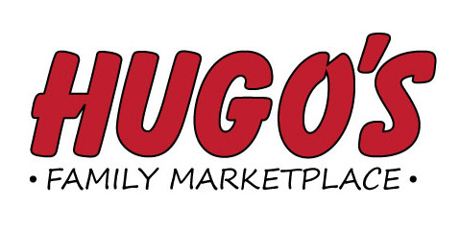
Job Opening
Overnight Bakery Truck Driver-Full time
(Hugo’s #3 Central Bakery, GF)

Duties Include: Providing Outstanding Customer Service,
loading and delivering bakery orders to the area Hugo’s
Store locations and other business accounts, working in the
bakery storeroom and freight receiving area, early morning hours.
Please send application to:
Hugo’s Human Resource Dept.
1950 32nd Avenue S. Suite C
Grand Forks, ND 58201
Applications will be taken through February 28th

