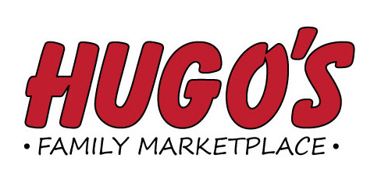
Job Opening
Bakery Manager – Jamestown

Duties Include: Providing Outstanding Customer Service, responsible
for all aspects of a full-service bakery department, baking,
scheduling, merchandising, training, ordering, monthly inventory,
book work and supervisory duties

Please send application to:
Hugo’s Human Resource Dept.
1950 32nd Avenue S. Suite C
Grand Forks, ND 58201

Or email: careers@gohugos.com
Applications will be taken through March 7th

